TESSA Secondary Science: Evaluation Report

Introduction
TESSA Secondary Science was a small scale project, within the TESSA programme which was funded by the Waterloo Foundation, from August 2010 to August 2012.
The project team had representatives from five partner institutions: Winneba University of Education, Ghana; Makerere University, Uganda; Egerton University, Kenya, Dar Es Salaam, University College of Education (DUCE), Tanzania and The University of Zambia, Zambia. Working together, the team produced 15 units of work to support teachers and teacher educators in teaching science in the lower secondary school. The units have since been versioned for Kenya, Uganda, Zambia and Tanzania.

Starting from an agreed vision for an effective secondary science teacher, the team identified five pedagogical themes. There are:
- Probing children’s understanding
- Making science practical
- Making science real and relevant
- Problem solving and creativity
- Teaching challenging ideas
Each theme is exemplified in physics, chemistry and biology. The topics chosen are relevant to the curriculum in all five countries and were chosen by colleagues on the basis that they illustrate the themes particularly well, or are notoriously difficult to teach.

The units are designed to support student learning and teacher learning. Through engaging in the activities and case studies, and trying them out in their classrooms, teachers will have the opportunity to learn about a range of teaching approaches and how to create classrooms that are inclusive and participatory. In all five countries, curriculum documents show that there is an aspiration that students should have the opportunity to construct their understanding of science concepts through dialogue and experimentation, and to develop a broad range of skills including problem-solving and creative thinking. These units are a response to that aspiration. They are available as Open Educational Resources, on the TESSA website.

The units became available on the website in 2013 and since then colleagues have been working within their institutions to implement the ideas embedded in the units in their teacher education programmes. The team remains in regular contact and meet annually at a conference: at the Distance Education for Teachers in Africa (DETA) conference in 2015, there were presentations from all five countries (see appendix 1). The purpose of this study was to gather evidence about how the units are being used and what pre-service teachers, teachers and teacher educators take from them, in order to inform further implementation work.

Do TESSA Secondary Science units have the potential to support student learning and teacher learning?

A detailed analysis of the TESSA SS OER was conducted as part of a doctoral study on teacher education. Drawing on the literature on student learning and teaching learning (eg Alexander, 2008; Borko, Liston, & Whitcomb, 2006; Desforges, 1995; Leach & Moon, 2008; L. Shulman & Shulman, 2007; Tikly & Barrett, 2011; Vygotsky, 1978; Westbrook et al., 2014), twelve themes (six for effective student learning and six for effective teacher learning) were identified. A sample of the units were analysed in order to determine the extent to which they have the potential to support student learning and teacher learning.
The themes are given below in Table 1, and the results of the analysis presented in Figures 1 and 2.

Table 1: Key principles that underpin effective student learning and teacher learning

Aspects of effective student learning | Aspects of effective Teacher Learning
Promote Inclusion | Present a vision for effective teaching
Build on prior knowledge and make learning relevant | Encourage collaboration
Build democratic relationships based on respect | Subject Knowledge, Pedagogical Content Knowledge, School knowledge of subject
Promote classroom dialogue | Reflection and noticing
Students challenged to develop a range of skills | Increasing teachers’ toolkit
Recognise the importance of tools to support learning – mental and physical. | Views of learner, learning and knowledge

Figure 1: Analysis of TESSA SS OER in terms of student learning. The chart shows the number of examples of each theme in the sample of units analysed. It shows that the units have the potential to support student learning, which each theme being equally represented.

Figure 2: Analysis of TESSA SS OER in terms of teacher learning. The chart shows the number of examples of each theme in the sample of units analysed. It shows that the units have the potential to support teacher learning, but that mediation is required to encourage reflection and collaboration.

Thus TESSA SS units should be useful to teachers and teacher educators. The results show that the TESSA SS OER have the potential to support student learning very effectively. They also support teacher learning, although two of the themes (reflection and collaboration) were less well represented. Mediation therefore needs to focus on promoting reflection and on providing a collaborative space for teachers and student teachers. This analysis informed the evaluation study by indicating what to look for and how to structure the analysis.

Methodology

This is a qualitative study, designed to gather evidence about how TESSA is being used in Tanzania and Kenya. The aim was to uncover the perceptions and understandings of teacher educators, pre-service teachers and teachers who use TESSA Secondary Science materials in their work; to gather evidence about the impact of the OER in schools and universities; and to identify opportunities for further work to embed the TESSA approach in both of the institutions visited. Dissemination of the work will enable colleagues elsewhere in the network to learn from others and reflect on their own work.
Two sites were visited: DUCE and Egerton University by the TESSA Secondary Science project co-ordinator (now TESSA Academic Director). This is the first formal evaluation of the Secondary Science materials and the advantage of the work being done by the project co-ordinator is that the data can feed directly into the planning of future work. There is a risk, however, that the data will not be viewed as dispassionately as it would be by an outsider and every effort has been made to report the findings in an unbiased fashion, highlighting the successes, but also the areas where further work is needed.

The investigation was guided by two questions:
- What do teachers, teacher educators and pre-service teachers take from the materials?
- How are the TESSA Secondary Science OER being used in the partner institutions in Kenya and Tanzania?
The intention is to use the evidence and conclusions from this research in order to consider a third question:
- How can the TESSA programme team best support secondary science colleagues in their efforts to embed the idea in the OER?

Data collection
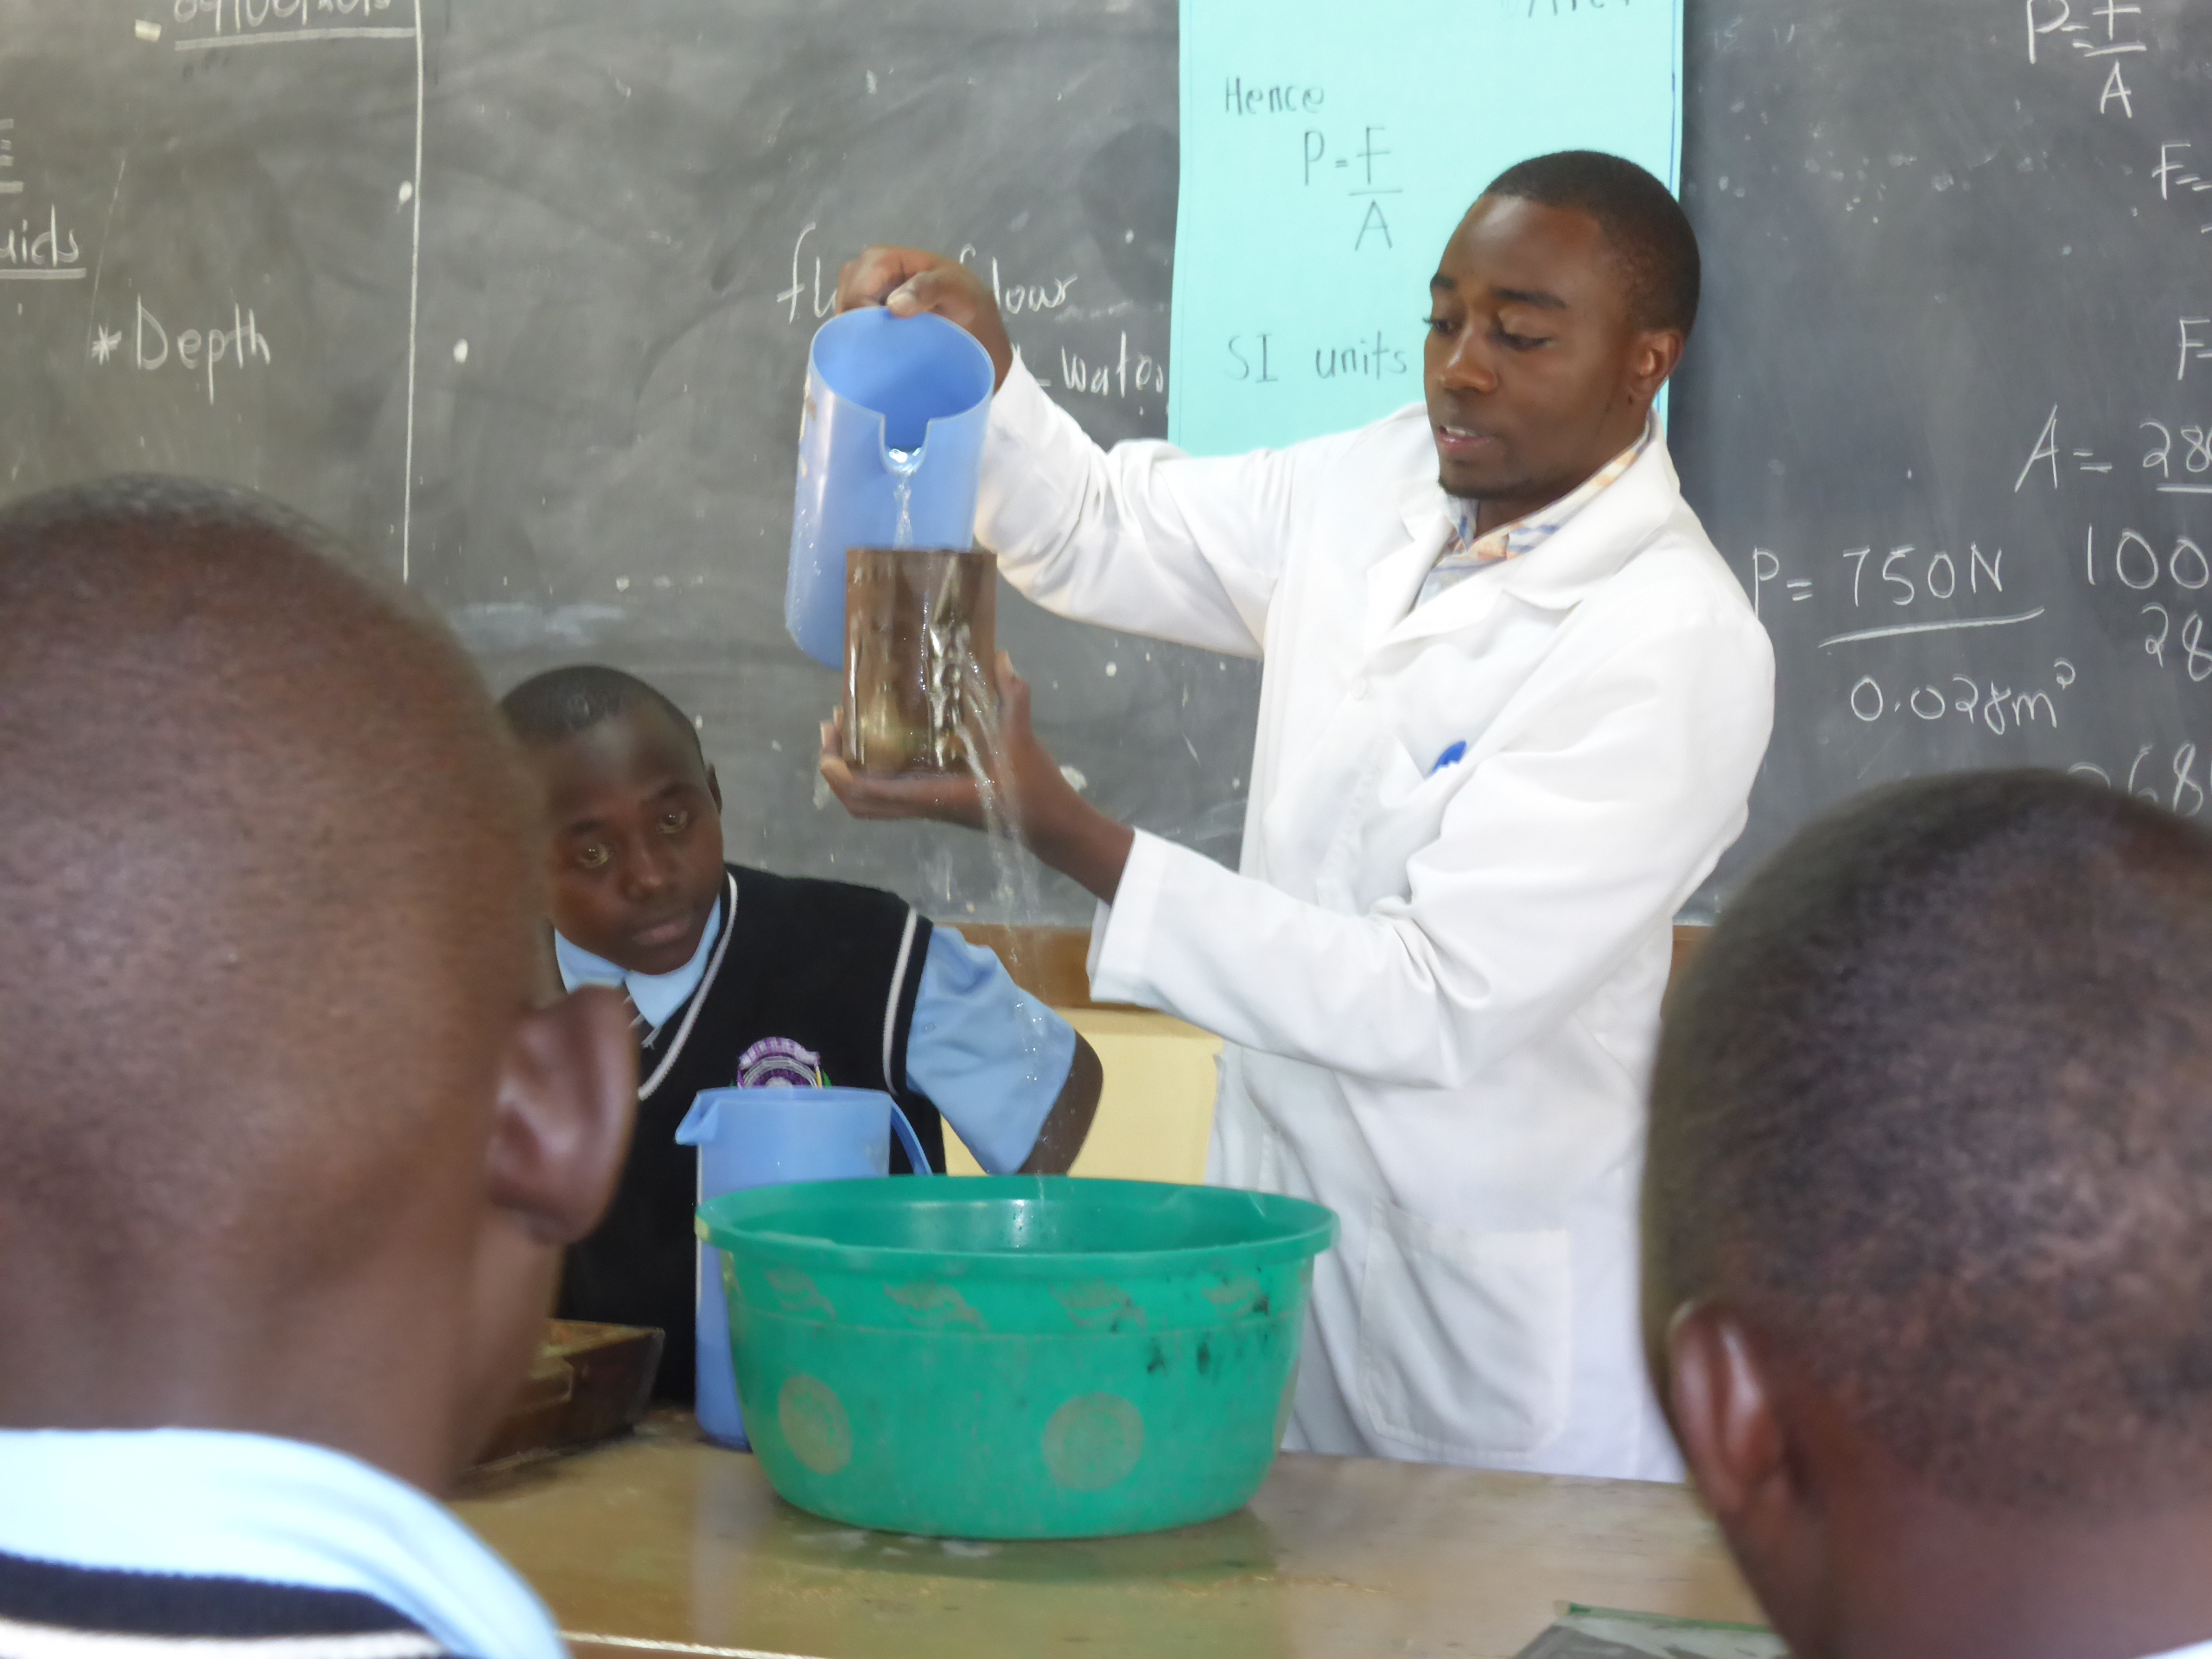
A student teacher conducting a demonstration, in Kenya
The evidence for the evaluation comes from a variety of sources:
- field notes kept throughout the visit;
- presentations by pre-service students at DUCE of lesson plans they had prepared for an assignment;
- three focus group discussions with teachers in Tanzania who had been introduced to the TESSA materials in a workshop run by the TESSA co-ordinator in Tanzania;
- three interviews with TESSA colleagues (teacher educators from Tanzania and Kenya)
- three interviews with teacher educators not previously associated with the project (two in Kenya and one in Tanzania)
- three lesson observations of pre-service teachers and two lesson observations of teachers who had been introduced to TESSA by the Kenya team.

Data analysis

The teacher educators who form part of the original TESSA Secondary Science team, work with pre-service teachers and teachers. It seems appropriate therefore to consider the research questions with reference to three different groups of people:
- Pre-service teachers
- Teachers
- Teacher educators
The interviews were transcribed and the data was analysed from two perspectives – a thematic analysis and an inductive analysis.

Thematic analysis

The data in this study was analysed using the themes that underpin effective student learning and effective teacher learning, in order to determine which of these themes are important to the three target groups. This demonstrated what, specifically, these educators take from the materials.

Inductive analysis

In order to identify how the materials are being used, the impact that they are perceived to make and conditions that support their use, a more inductive approach to the data was used with recurring themes identified and checked. Detailed field notes were used to confirm or reject findings rather than as a primary source of data.
The themes that emerged as being important were:
- the pedagogical themes that underpin the units;
- access to the OER;
- mediation;
- link to policy;
- relevance to the curriculum.
Evidence for these was identified amongst the various groups.
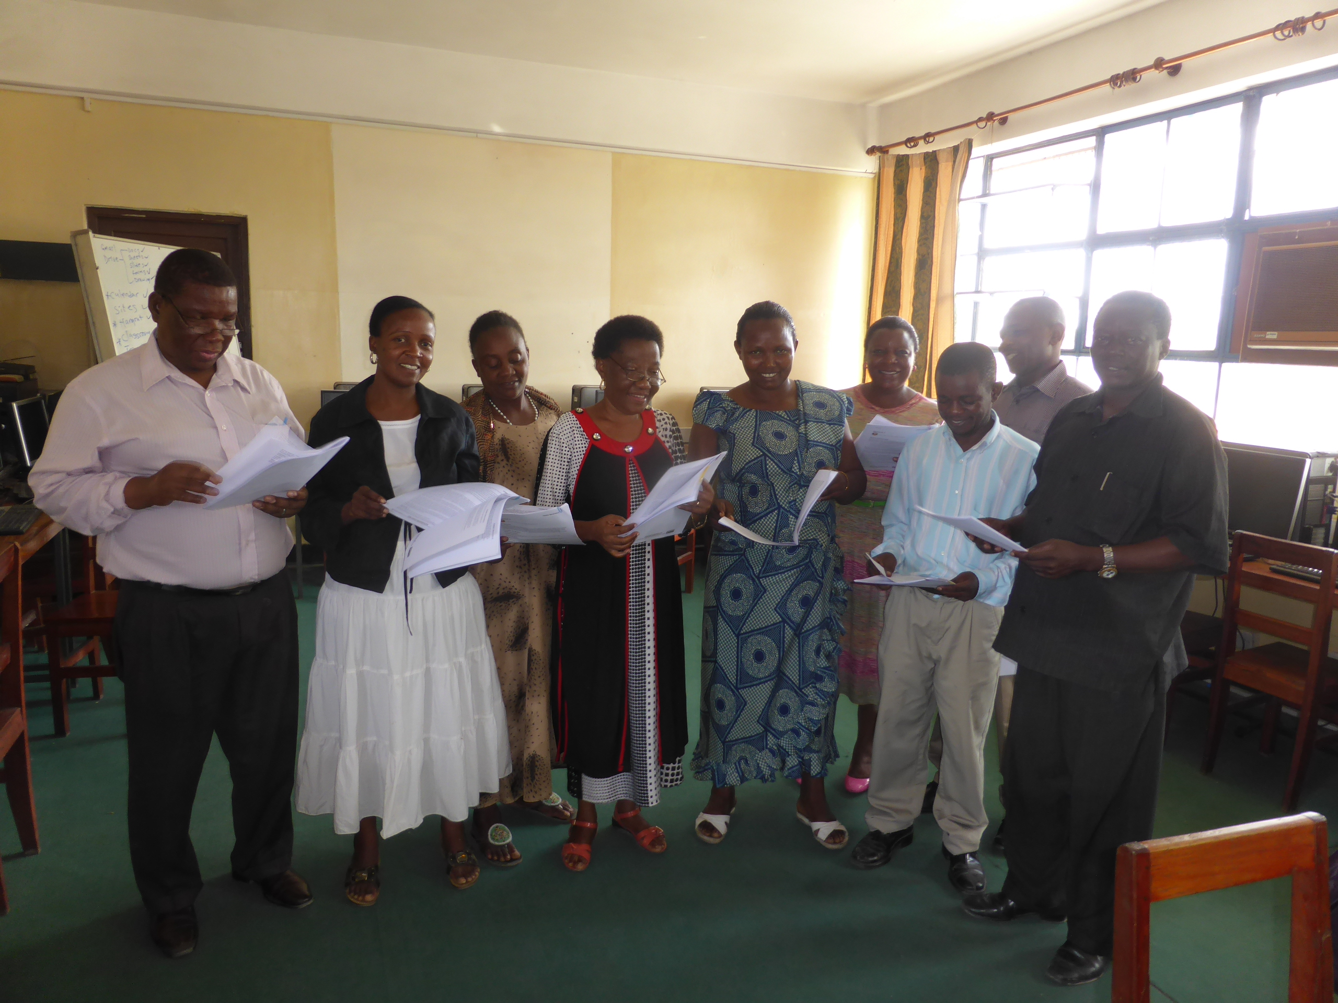
Focus group Teachers in Tanzania
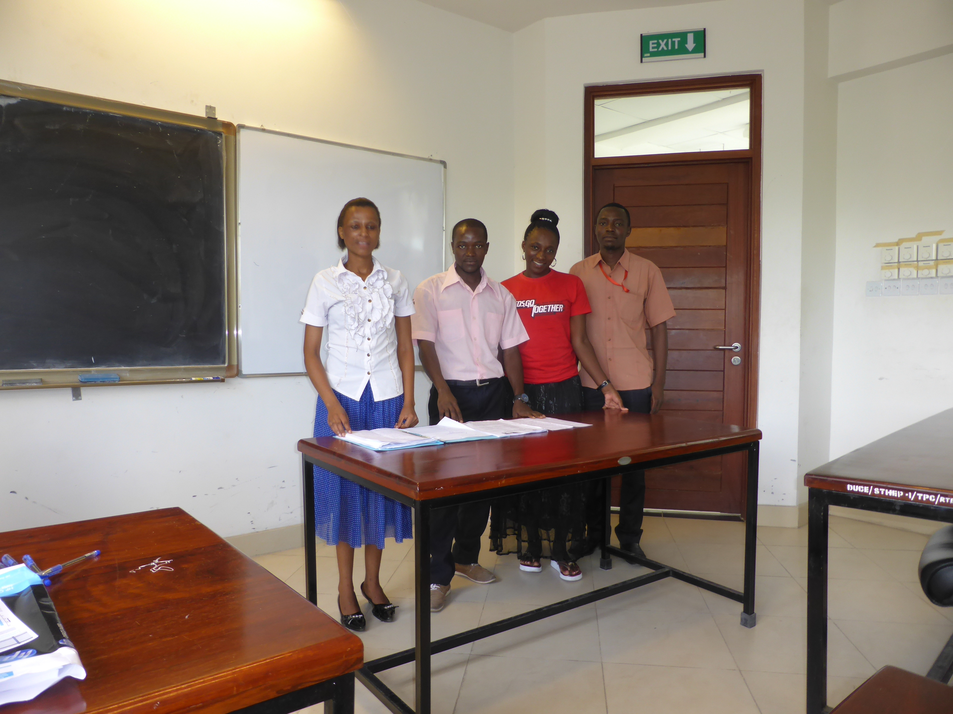
Student teachers in Tanzania, presenting their lesson plans

Findings

Teachers
The teachers identified a number of ways in which the units support teacher learning.
The way in which teacher education programmes are organised with ‘subject’ being taught in one department and ‘methods’ being taught in the Education Department, means that pre-service teachers in Africa have limited opportunity to develop their ‘pedagogical content knowledge’ (L. S. Shulman, 1986) – how to teach the subject rather than about the subject. The teachers interviewed recognised that the units are very helpful in this respect as they fill that gap:
‘they help me in preparing practicals. Knowing the steps, how to take, how to do with the students, by preparing a good material before and during the practicals. It help me much. Before I was having some problems in doing practical, but now …’(TD)
The units are helping teachers to develop their own ‘toolkit’ – a set of teaching approaches that will enhance their teaching.
These include brainstorming……
But there are those resources giving you guidance when you are using brain storming. Questions to ask and how to, to involve the students and how to conclude it on that topic that you introduced in the classroom. So now at least systematically I can do brain storming.
…..and strategies to help students understand scientific vocabulary.
Until we finished that year those students were not able to write the word ‘chloroplast’, because I didn’t make them practice to write the words. While I was designing the activity, where they would write the parts of the cell in the cards and exchange and write at the practice, then they understood how to write those, those words.
Through using the units, teachers began to realise what their students are capable of and to give them more responsibility. This teacher liked to make sure that all her students got the ‘right’ answer, but is beginning to understand that their own formulations and explanations are just as valid.
…then I group them so that we solve the questions. The same question is attempted by all groups. And then in groups they get the idea. It may be different to another, but they get the same meaning.
……and that when students are given the chance to be actively involved, they benefit
And I know that I was ……. doing more of the lecture method, rather than involving them, the students. There are certain topics that I was thinking that they are, it is not easy to design an activity. But I saw activities here, in these materials designed it and I saw that this can be done in the classroom and the students can understand easily. So I don’t think the student have any problem with that, working with these methods. I think I was the one who was denying them the chance to work by themselves.

The teachers also acknowledged that the units support student learning….
I know that when I use these techniques students become better active involved and they understand more.
……and give students more confidence
Most of the students, during the practical session, or during doing practical, all the students are active in the class. They were not confident.

Teachers agreed that the units help them to plan active lessons, and like the way in which they provide ideas for alternative resources if the ones described are not available.
‘there are some very good, more useful ideas have been getting from the materials.

In most of they, they make student (Teacher?)to be creative and to find the other alternative materials, apart from those which are just available. When you look on the resources of TESSA on the topics which have been developed, they have got more materials, more alternatives I mean.
There was also evidence in Tanzania and Kenya that teachers are taking ideas from the TESSA OER and applying them to different subject areas.

Some of the teachers acknowledged that the TESSA units were helping them to change their practice, but also that once they do so, they find themselves listening to their students more carefully
Because I used to use only the lecture, yeah. But now, this one will help me to make students learn by themselves, not by using lectures.

I found that when you divide groups for discussion you find that you can get different ideas on the same concept from different groups.

The specific links to the curriculum are very important to teachers – as they browse the units they are always pleased to find activities based on specific, familiar experiments.
Most of the teachers taking part in the study access the units in print form. Many of them possess ‘SMART’ phones, but very few use the phones for work purposes.

Student teachers
The evidence from the student teachers was gathered through the observation of presentations of lesson plans and lessons taught on teaching practice. The observation notes suggest that student teachers appreciate how the TESSA OER help them to support student learning. One student teacher specifically mentioned the fact that the OER are inclusive when presenting his plan, and had helped the group plan for all learners. Two of the student teachers observed were pro-active in their attempts to involve everyone, walking around the room and noticing how students were progressing with the tasks that had been set. One had used the ‘questioning’ resource and various techniques for responding to student questions were in evidence.
All the students had taken the message that it is important to build on prior knowledge, but in all cases this was limited to asking questions. The examples in the plans were generally short, closed questions.
Two of the lessons and all the plans included opportunities for students to talk together about their ideas.
There was a noticeable difference between the plans and the observed lessons, with the former being consistently undemanding of the students. There was nothing in the plans to suggest that a good lesson does more than deliver content, but also supports students in learning how to learn by making use of physical and intellectual tools. There was also very little attention in the plans on what the students might be doing and the tone was very much of the teacher as ‘expert’ with students as passive absorbers of knowledge. However, all the lessons included some practical activity and, depending on how the teacher behaved in the lesson, then this might come through. The explicit links to the curriculum were considered to be very important and a strength of the materials.

Two of the observed students had embraced the TESSA materials and had adapted activities to suit their curriculum needs. One in particular saw TESSA as giving him the license to be the sort of teacher that he wants to be, even though he had no role models in his partner school. In fact, the teachers he is was working with were coming to him for help and guidance. However, one observed student had not accessed the TESSA OER.
Students had been shown the TESSA website, but seemed to be reliant on printed materials. The challenge is that teacher educators tell their students about the resources, but are not in a position to supply hard copies. In Tanzania, in a class of over 200, only around 20 students had printed them out.
The problem of access is being tackled however elsewhere and a teacher educator in Ghana described in a conference presentation how she had taught her students to use their mobile phones to access TESSA materials.

Teacher Educators
The overwhelming message from the three teacher educators who have had no previous involvement with the TESSA team is that they saw the materials as being for teachers and not for them. Two teacher educators (one in Kenya and one in Tanzania) told the students about the materials, but did not attempt to give any insights into what the students might get from them.

Now during those lectures I told them that in preparing lessons we have, apart from the materials we used to, we have TESSA materials, so we can get the materials from this website I gave them (ND)

Did you explain how the materials are different from the text book? No, I didn’t. But I told them to read the materials and compare to the text book they are using.

The course outline in one of the institutions contains a reference to TESSA, in the section on ‘teaching resources’, but the impression is that it is an ‘add on’, not an embedded resource that is referred to at different times in different contexts.

Students are taught the science content in the science department and one teacher educator acknowledged that this is a problem. I will start by saying that this is where we have had a problem. Because quite a number of lecturers in the Faculty of Science are not trained teachers. However, his own view was that students need to understand the content before you can teach them about pedagogy. And the understanding has been that before you can talk of pedagogy, before you can talk of communicating, you have to have that thing that you need to communicate. There was no sense that you could teach the two together by modelling the pedagogy in order to teach the content.

The observation of a teaching session provided an example where the ideas embodied in the TESSA materials would have greatly enhanced the student teachers’ learning, but content and method seem to remain completely separate in the minds of teacher educators. The session was on ICT – how to use word and in particular the review functions (track changes and comments). Students were invited to write a short piece of text and then to review each other’s work. They could write it on whatever they wanted. This would have been an opportunity to support subject knowledge development, by asking students to work with someone from their own subject area and to write a technical piece about their subject. In this way, they could have practised the ICT skills, but also taught each other some subject content.

Some of the teacher educators had been involved in the development of the materials. It was clear that their experience of working on the project had influenced their own work.
I don’t lecture on content as I used – I asked the students to prepare a scrap book based on their own research. They worked in groups and I supported them.
However, he went on to explain that this was only possible with small groups of students.
TESSA has helped me to improve my own teaching, but when asked if his colleagues were using TESSA he explained that he has introduced them to the materials but was not sure about the extent to which they are being used. There is no forum where these issues are discussed. This is despite the observation that the students who take up TESSA become better – very innovative and creative.
The impact on students was also highlighted by another teacher educator: Definitely those who use TESSA materials aggressively will do better in the microteaching, peer teaching and also in teaching practise.

Thus evidence suggests that despite the impact on students, the TESSA approach has not spread far beyond the original team. In one institution, the Chairman of the Department suggested that TESSA is not yet very strong. This is because TESSA colleagues often get promoted to new roles with more responsibility but less teaching.

One of the original team has travelled extensively around his country running in-service training sessions for teachers. He has had considerable reach and has trained many teachers. The explicit links to the curriculum and the prevailing policy agenda are significant in his role. However, I met three different groups of teachers whom he had trained and there was little evidence of lasting impact. He showed me the presentation he uses and although it included some activities to engage participants, it conveyed the ‘form’ rather than the ‘substance’ (Brodie, Lelliott, & Davis, 2002) of learner-centred teaching. This means that it included some of the approaches but that they were not underpinned by the attitudes and values of LCE, and are therefore unlikely to be sustained. However the strong link with the policy agenda and the rapidly improving internet connectivity in Africa, means that interest in the OER is increasing. Invitations to make presentations at the University of Nairobi (not previously a TESSA partner) and at the ‘Innovation Africa’ conference in Nairobi in September 2016 demonstrate that interest in OER specifically designed to support the school curriculum is growing. Work in Zambia has also shown that, although the materials were written in 2012, they are very relevant to the revised school curriculum as they help teachers to address ‘skills’ and ‘values’.

Discussion
This study was framed by three questions:

- What do teachers, teacher educators and pre-service teachers take from the materials?
- How are the TESSA Secondary Science OER being used in the partner institutions in Kenya and Tanzania?
- How can the TESSA programme team best support secondary science colleagues in their efforts to embed the idea in the OER?

This small scale study suggests that in the hands of teachers and student teachers, TESSA SS OER have the potential to improve the classroom experiences of pupils. Two student teachers observed on teaching practice had embraced the TESSA OER enthusiastically and this showed in their teaching. They organised meaningful tasks, which engaged students and talked directly about how TESSA OER had influenced their teaching. Likewise for two teachers observed in Kenya and one of the focus groups in Tanzania. These teachers talked about adapting TESSA ideas to new topic areas and are accessing them online on phones.
Teachers and student teachers take from the units practical advice that they need in order to support more active approaches to learning. They specifically referred to the themes of making science practical and making science real and relevant. This is material which is not specifically taught on teacher education programmes, yet it is what student teachers and teachers need to know. The observations suggested that there is an appreciation that teaching should build on prior knowledge and understanding, but the theme of creativity and problem-solving is proving to be more demanding to embrace.
There is also evidence that through working in this way teachers get to know their students better; they appreciate more what their students can and cannot do and give students chance to provide their own explanations of scientific phenomena. This is particularly significant because it is what will eventually lead to the changes in attitude that produce sustainable change. The strength of the vision for good teaching that comes through in the TESSA OER means that once student teachers and teachers engage, the impact of the TESSA SS OER on the quality of teaching is significant.
Thus, TESSA SS has started to make a significant contribution to improving the quality of teaching in line with policy aspirations.

The challenge lies in the universities and colleges where teacher educators acknowledge the benefits that TESSA OER have; they direct their students to the website, and where possible provide printed copies. TESSA OER have been used to support teaching practice, micro-teaching and planning, and the students who embrace the materials do particularly well. However, the separation of subject learning and methodology learning means that integrating TESSA OER into teacher education programmes is problematic and means that the teacher educators themselves do not automatically draw on the materials in their own teaching. There is not yet widespread modelling of active pedagogy on teacher training courses, and some teacher educators lack basic skills, believing for example that active learning is not possible in large groups.
However, it needs to be acknowledged that involvement with TESSA has had a significant impact on the original project team. Many have since been promoted; they have had other international experiences and have grown professionally. In the next phase of TESSA, this is something that could be capitalised on. Working with TESSA has also led to innovative approaches to CPD. For example, in Kenya, university-based teacher educators organised a workshop for their colleagues and local teachers. University lecturers and teachers worked on activities together, as equals. Normally, the teacher educators are seen a ‘experts’, so positioning them as learners, alongside teachers sent a powerful message.

This study has a number of implications for the TESSA programme.

- Access to the TESSA OER is crucial. Work needs to be done to develop the website, to provide practical examples of use and to encourage people to use phones and other devices that they might have to access the OER.
- In the hands of teachers and student teachers, TESSA OER can improve teaching. New developments need to involve finding ways to integrate TESSA OER directly into school in-service programmes, so that more teachers are exposed to the resources and supported in using them in their work.
- The work of the TESSA programme has created a pool of local activists – enthusiasts whose own teaching has benefitted from their involvement with the programme and the use of the TESSA OER in their work. This is something that we could capitalise on by finding ways to better support their work, and encourage more collaboration within institutions so that the ideas spread more rapidly.

Acknowledgements
This work was funded by a grant from The Allen and Nesta Ferguson Foundation.
Grateful thanks go to my colleagues in Tanzania and Kenya who hosted my visit and arranged the opportunities to meet teachers and student teachers to discuss TESSA. Finally, I am grateful to the student teachers who welcomed me into their classrooms and presented their lesson plans.
A student teacher in action. A highly interactive lesson, drawing on ideas from TESSA

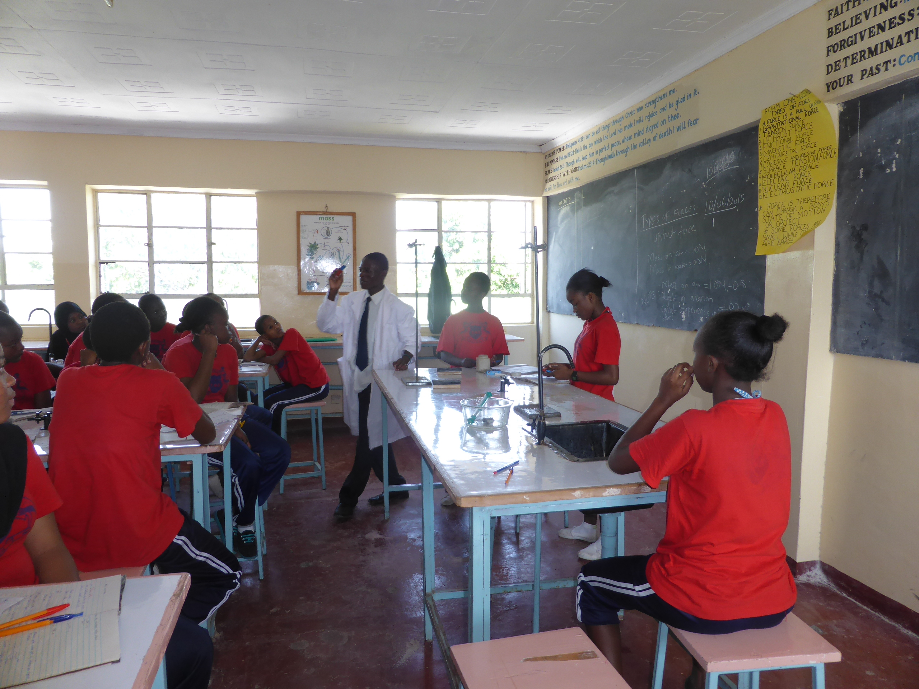

References
Alexander, R. (2008). Education for All, the quality imperative and the problem of pedagogy. In Create Pathways to Success. Research Monograph No. 20. London: IoE.
Borko, H., Liston, D., & Whitcomb, J. A. (2006). A Conversation of Many Voices: Critiques and Visions of Teacher Education. Journal of Teacher Education, 57(3), 199–204. https://doi.org/10.1177/0022487106287978
Brodie, K., Lelliott, A., & Davis, H. (2002). Forms and Substance in learner-centred teaching: teachers take-up from an in-service programme in South Africa. Teaching and Teacher Education, 18, 541–559.
Desforges, C. (1995). How does experience affect theoretical knowledge for teaching? Learning and Instruction, 5, 385–400.
Leach, J., & Moon, B. (2008). The Power of Pedagogy. London: Sage.
Shulman, L. S. (1986). Those who understand: Knowledge growth in teaching. Educational Researcher, 15, 4–14.
Shulman, L., & Shulman, J. (2007). How and what teachers learn; a shifting perspective. Journal of Curriculum Studies, 36(2), 257–271.
Tikly, L., & Barrett, A. (2011). A starting point for reconceptualising education quality and how it can be evaluated. International Journal of Educational Development, 31(1), 3–14.
Vygotsky, L. (1978). Mind in Society: The development of higer pyschological processes. Cambridge: Harvard Iniversity Press.
Westbrook, J., Durrani, N., Brown, R., Orr, D., Pryor, J., Boddy, J., & Salvi, F. (2014). Pedagogy, Curriculum, Teaching Practices and Teacher Education in Developing Countries. http://eppi.ioe.ac.uk: Education Rigorous Literature Review. Department for International Development.

Appendix 1: TESSA SS presentations at DETA 2015

Jovita Katabaro (University of Dar Es Salaam): Uses by and challenges from teachers using TESSA print materials in secondary schools in selected Tanzanian schools.

Inspired by a meeting with the PM of Tanzania, Dr Katabaro has taken TESSA Secondary Science materials to some rural schools in Tanzania.

The context is that in Tanzania there is considerable variation in educational provision. In urban areas, schools are often fairly well-equipped, whereas in rural area, many schools do not have electricity, there is a shortage of teachers (particularly in science) and an acute shortage of books. There is poor participation in Science and pass rates in Maths and Science are low.
Print copies of the TESSA Secondary Science OER were sent to three participating schools. This was followed up by a visit in order to determine how the OER had been received and used. Two of the schools had no electricity and they all reported a shortage of books. The teachers were interviewed about their perceptions of the OER. They were pleased that they matched the curriculum and acknowledged that they were helpful to them, particularly in planning practical activities. It was clear, however, that mediation is required in order to help the teachers understand the potential of active-learning in motivating students. Most of the teachers would not be able to access the materials other than through print. However, some had smart phones, so training in how to use them effectively would be helpful.

Henry Busulwa (Makerere University): Attitudes and coping practices of using mobile phones among secondary schools stakeholders, Uganda

This project demonstrates that changing attitudes towards the use of mobile phones is a slow process but that potential rewards are worth striving for.

Mobile phones – particularly those capable of accessing the internet - have the potential to support student and teacher learning. However, many schools have a policy which bans the use of mobile phones in school.
Henry and his team worked with a private school in Kampala. They drafted guidelines on mobile phone use and shared them with stakeholders. They persuaded the school Board to install Wifi in the school and introduced teachers and parents to the potential benefits of using mobile phones in school.
They encountered considerable resistance, with only 18% of teachers, 9% of parents, supporting the initiative – but 95% of students. After one term, people were beginning to notice improvements. In particular, students talked to their parents more about their learning and teachers were beginning to realise the potential of phones and OER, and were asking for more training.
This study demonstrates how attitudes can be changed and the advantages of a small-scale initial study as individual problems and concerns can be raised and discussed.
The focus was not necessarily on TESSA OER, but as Henry said ‘through TESSA I have become brave enough to interfere’.

Patriciah Wambugu and Fred Keraro (Egerton University): Challenges of embedding and extending TESSA Science OER for effective pedagogy in secondary schools in Kenya
Patriciah and Fred organised a workshop for teachers and teacher educators in order to introduce TESSA Secondary Science OER, and reflect on the challenges of embedding them in teaching.
Patriciah explained how the TESSA OER support the aspirations of Kenya Government Education policy. She organised a workshop for teachers and teacher educators, in which they worked together in groups in order to understand TESSA OER and plan for their use. This was a novel experience for both, as conventionally teacher educators see themselves as experts; in this workshop they were working with teachers as participants. The workshop was followed by interviews and observations with teachers. The evidence shows that where a TESSA ‘champion’ emerges, they influence their colleagues. However, a number of challenges remain including the support for student teachers in schools, the attitudes of many teachers and teacher educators and school administrators’ attitudes towards OER.
Teacher educators have told pre-service teachers about the materials, but the evidence suggests that they need to more than this. More active mediation of the OER is required.

Simon Shayo (Dar Es Salaam University College of Education): Science teaching and learning using TESSA material in Tanzania

Simon is a National Facilitator for CPD in Science. A cascade model for CPD operates in Tanzania and Simon explained his work.

The Tanzanian Government has adopted a ‘competency-based curriculum’ and supports a programme of CPD across the country. Simon is one of 60 National Facilitators of CPD (15 each in Maths, Physics, Chemistry and Biology), who between them have trained 20 regional trainers per subject in each region of Tanzania. These regional trainers have trained local teacher educators. Through this process, thousands of secondary science teachers have been exposed to TESSA OER. Simon has also been working with Colleges of Education in order to raise awareness of TESSA OER in particular and OER in general.
In a survey, teachers reported that their pedagogical skills had improved; that there was more interaction in their classrooms and that the TESSA OER are valuable reference materials. A lack of connectivity and poor ICT skills remain a problem. Simon is convinced that in the future a focus on improving ICT skills and encouraging hand-held devices is important.

Kris Stutchbury (The Open University): What are the characteristics of materials designed to support teacher learning?

Kris has developed a framework which highlights the characteristics of materials to support learning. TESSA Secondary Science OER have been analysed against this framework, highlighting the strengths and weaknesses of the materials

The TESSA Secondary Science OER were written collaboratively by expert practitioners, drawing on years of practical experience in different contexts.
Based on the literature about effective student learning and effective teaching learning, a framework was developed, which describes the characteristics that we would expect such OER to have.
9 TESSA Secondary Science units were analysed against this framework in order to identify any gaps and gain insights to support mediation. Each unit was analysed from two perspectives: student learning and teacher learning.
The analysis showed that in the hands of a confident and motivated teacher, the OER can effectively support student learning. There were examples of all 6 principles identified from the literature. As far as teacher learning is concerned, the OER strongly support the development of Pedagogical Content Knowledge. This is not surprising as this is what is acknowledged to be missing from many teacher preparation programmes where subject teaching is separated from ‘Methods’, often being taught in separate departments. The materials do less well in supporting reflection and encouraging teachers to work collaboratively to develop their skills. The suggestion is that these areas could form a focus for mediation of the OER with in-teachers and pre-service teachers.

Kaulu Goodwell (University of Zambia): Using TESSA OER to improve girls’ participation in Science in Zambia
Goodwell took part in a small-scale project to investigate the impact of TESSA Secondary Science OER. On the basis of this, the University of Zambia have secured funds for a major study designed to find ways of encouraging more girls to study science
In an effort to find more effective ways of Improving girls’ participation and achievement in Science in Zambia, a small-scale project was carried out in Lusaka to investigate the impact of TESSA Secondary Science OER. The study suggested that the pedagogy embodied in TESSA OER encourages girls to take a more active part in science lessons. On the basis of this, the OER will be utilised by several senior secondary schools in Zambia and shall further be tested in a major study, designed to find ways of encouraging more girls to study science.
The large scale study is to be funded by the National Science and Technology Council of Zambia (NSTC). It will start with students across a wide region being given a science test. Half of the teachers will be introduced to TESSA OER and encouraged to use them while the other half will continue with their usual teaching approaches. The students will be tested again after some time to see if there will be any significant difference in performance between those in the experimental and control groups. Planning is currently underway about how the teachers will be introduced to the OER.

Sakina Acquah (University of Education, Ghana): Interactive approach of introducing TESSA OER for extensive use: a focus on student teachers of UEW.

Sakina explains how she changed the way she introduced pre-service teachers to TESSA OER and the impact it has had.

For the last three years, pre-service teachers studying for a BEd at the University of Education, Winneba have been introduced to TESSA and other OER during her science pedagogy lessons. However, the impact on hands on activities has been limited.
Sakina noticed how many of the pre-service teachers have smart phones, laptops and tablets, so she changed her approach. She asked as many students as possible to bring their phones, laptop and tablets to one of her teaching sessions. She divided them into groups, making sure that each group had access to a reasonable number of phones and other ICT tools. Using a projector, she led them through the process of accessing and downloading OER, starting with TESSA. She noticed that many lacked some basic skills, but that they learnt very quickly, and rapidly gained confidence, supported by their peers. 92 students were involved, and 15 joined a focus group so that Sakina could investigate their attitude towards this approach. The students are learning to teach in Basic Schools and will therefore need to teach a range of subjects. Within a relatively short period of time, she noticed that they were starting to use materials in a range of subjects, even though the initial focus had been on Science.
The study demonstrates the benefit of active mediation of the OER and the importance of creating conditions in which students can collaborate and learn from each other.

