Influence of Biology Education on use of Natural resources: A case study on use of Natural Products from Pece Wetland, Gulu District Uganda.

By Busulwa H. S and S. Ojokit Odongo
Department of Science Technical and Vocational Education
School of Education
Makerere university
P. O. Box 7062
Kampala, Uganda.
hsbusulwa@cees.mak.ac.ug

Abstract:

The increasing reports on environment degradation and over exploitation of natural resources are blamed on a population that is ignorant on the roles and services of natural ecosystems. A majority of people who are involved in environment degradation and over exploitation of natural resources have studied biology education, a science subject which deals with natural issues that has been taught for many years, since formal education started in Africa. This study investigated the relevance of the biology learnt at schools, in the utilization of the natural products giving a case study of Pece, a natural wetlands near Gulu town, in northern Uganda.

Data was collected from school leavers, local council leaders, environment officers’ and communities using a self-administered questionnaire and interview guide so as to assess the influence and impact of the biology education learnt on use of natural resources. The findings reveal that the biology knowledge taught in secondary schools had no significant influence on the use of wetland resources. The skills used in the extraction of resources from the natural wetlands were most learnt by informal education through the users’ family or community contacts rather than in classroom.

Hence the TESSA approach in upgrading Science education resource materials is important in aiding learning that enhances application of the relevant aspects of use of natural resources. School leavers who complete tertiary education and have studied biology education should benefit from a curriculum that educates them on the importance environment and natural resources for sustainable development. The study recommends engagement of biology educators in production of resource materials that promotes teaching-learning to make learners acquire knowledge, skills and values and apply them while using natural resources. Research on traditional and cultural knowledge that promote the learning of biology to promote environmental literacy is recommended especially at this generation of people who should be sensitive to climate change issues. The biology curriculum used should therefore be broadened to encourage critical thinking of the learners in the various careers prospects that include use of environment in supporting livelihood.

Key words: Biology education, natural resources.

Introduction

The media reports about environmental degradation in Uganda are include severe droughts, landslides, flooding, deforestation, wetland degradation and over exploitation of natural resources (NEMA, 2010, Kizito, 2008). Such degradation continues to occur and affect many ecosystems in Uganda, and is responsible for the poor health, poverty and lack of alternatives to support livelihood to improve household incomes (Mwanje, 2010). The misuse of natural resources goes on despite the fact that many of the resources users and beneficiaries have been exposed to environment and ecosystem dangers through the biology education taught at school. Sometimes the degradation is largely blamed on irrational needs for survival, but it is done by people who have been to school and have studied science and probably been exposed to the importance of environmental studies through biology lessons in secondary school.

One of the main effects of environmental degradation is manifested in biodiversity and habitat loss. People continue to extract natural resources without appreciating that they are beneficiaries of the biology education they learnt during their school times. Their activities on natural resources results into wetland reclamation, pollution, soil erosion, deforestation and water loss to mention a few. School leavers who have been exposed to biology education should be agents of conservation. The value of biology education therefore becomes questionable if it does not assist conservation efforts. The TESSA approach (Kris, et al 2013) is a likely solution that has come to continually develop and upgrade resource materials to make learners appreciate what is taught in biology lessons. The skills that would empower leaners in being sensitive to the environment around them are inadequate taught during biology lessons but this would also assist in the implementation of government policies and guidelines concerning environment conservation and promote sustainable use.

Biology education in Uganda is a component of the science curriculum and is a compulsory subject at the Uganda Certificate of Education, that is, it is taught up to ordinary level (‘O’ level). The subject exposes learners to scientific biological knowledge, skills and values needed to understand life and its processes together with the environment. The learning of biology focuses on enabling learners to manage their health by mainly sensitizing them on common diseases and infestations in both families and communities (National Curriculum Development Centre [NCDC], 2008). It also includes some aspects of ecology that enable learners to be exposed to the role of habitats and ecosystems integrity as drivers of life processes. Hence because of its importance, the Government of Uganda passed a policy that biology is among the compulsory science subjects to be done by every ordinary level student (MoES, 2005), for it addresses the linkages between life processes and environments and their relationships with human beings. In particular Biology should aim at equipping students with knowledge that enable them to eradicate the basic environmental illiteracy that surrounds them; empowers them with basic skills to exploit the environment for self- development, better health, nutrition and family life, and the capacity for continued learning (Government White Paper on Education, 1992). Schultz (1971), A good number of people who would go through lower secondary level training (Kafuko, 2000), would therefore be conscious of the effects of environment degradation (Isingoma 2005).

However, the biology education syllabus in Uganda is silent about many issues concerning people’s survival, yet not all school leavers in Uganda completed O’ level and even those who complete will need to use the experiences of biology even if they do not proceed with it in gainfully careers. Many people’s livelihood depend on extraction of natural resources through continued removal of extractable materials that are physical or alive and this lead to ecosystem degradation. Indicators of ecosystem degradation include constant food shortages, disease prevalence, high population growth, induced laziness and dependency among others (State of Environment Report, 2006). The degradation is done by people who have been to school. The biology education seems not to empower the people to guide them on use and extraction of the resources they depend on. Degradation of ecosystems occurs in both urban and rural settings and includes back-filling and re-claiming of the wetland and forests with construction of commercial centres, human settlements, waste disposal sites, sand and clay extraction, to mention a few. These activities would cautiously be planned by people with a better understanding of setting up activities in such fragile ecosystems. Hence the approach to teaching of biology education and its development of resource materials need to take advantage of the need that the natural biological resources will continue to offer support to livelihood.

Objectives of the Study
This study investigated the application of the biology education by secondary school leavers who use wetland resources of an urban Pece wetland, in Gulu district, Uganda. Specifically the study aimed at:
  - Investigating the application of the knowledge from biology education learnt at school while using of wetland resources from Pece wetland.
  - identifying the conservation skills acquired through learning of biology that are necessary in use of wetland resources.
  - Assessing the non –formal education influence on the gain of knowledge on wise – use of the wetland resources.

Study Area
This study was conducted between February 2011and February 2012 at Pece Wetland in Gulu District, Uganda. The wetland (Figure 1), drains much of the municipality water and wastes, and has natural vegetation with a permanently wet zone. The community is composed of varied educational and socio-economic backgrounds. School leavers who had benefited from various levels of biology education were the key informants. They directly benefited from extraction and use of wetland resources. The study also involved some residents around Pece wetland, local leaders, environmental officers, and curriculum developers and implementers.

Methods
The study targeted a sample of 100 school leavers out of which 54 respondents participated in the questionnaires survey. Another group of 30 participated in focused group discussions and interviews. The discussion groups involved participation of Environment officers and field staff, Local Council leaders and communities, and teachers. Observations were made on use of wetland resources and the states of the wetland resources were recorded.

Results and Discussion:
Table 1 shows the background information of the respondents who participated in the research.

Table 1 Background information collected from Resource users of Pece wetland

Factor | Category | Frequency | Percentage  (%)
Age (in years) | <20  21-30  31-40  >41 | 4  29  11  10 | 7.4  53.7  20.4  18.5
Sex | Male  Female | 43  11 | 79.6  20.4
Household population | <5  6-10  >10 | 18  32  04 | 14.8  22.2  63
Marital status | Married  Single (including widowed) | 38  16 | 70.4  29.6
Age at which married (years) | <20  21-30  >31 | 12  30  01 | 22.2  55.6  1.9
Total |  | 54 | 100%

From the table above, the highest percentage (53.7%) of the wetland users were youths in age range of 21 – 30 years. These had left school and were the physically active group. Together with those below 20 years (7.4%), they participated in the focus group discussion and extracted resources namely clay, sand, water, and reeds/grass/ papyrus as means to support livelihood. Respondents said as follows:
‘We always make bricks from here, for sale to get school fees and other personal requirements.’
“I prepare these papyrus for making mats and the strings for other works. My daughter in-law cuts them and brings them here, after making; she carries the mats to the market (for sale).”

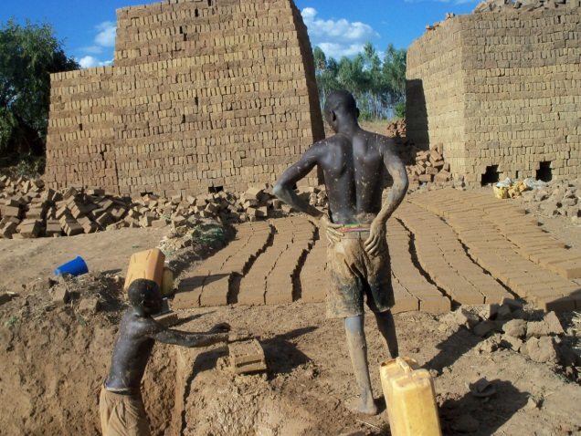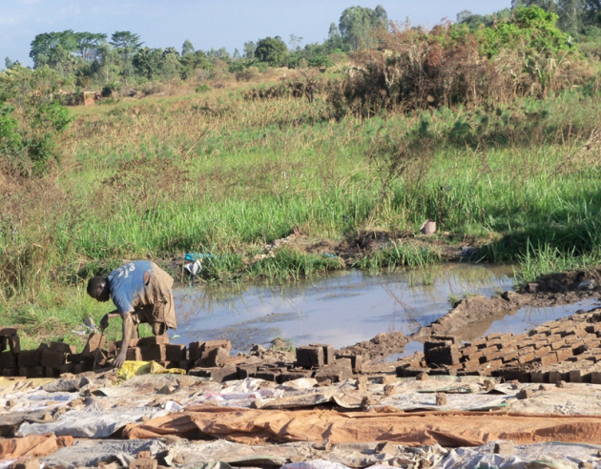

Plate 1: Young people make use of the wetland resources at the wetland site.

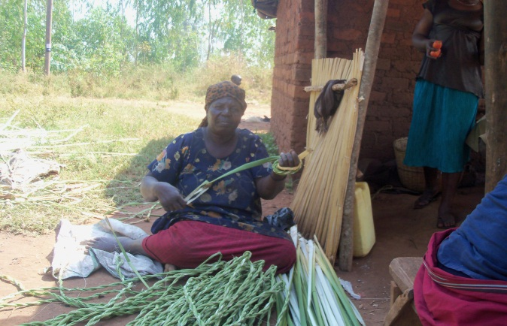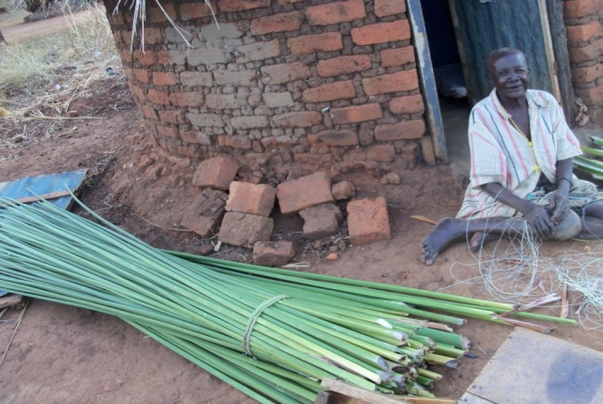

Plate 2: Older people process extracted wetland resources at their homes
Regarding gender, there were more males (79.6%). Women were more available in the focus group discussions. This implied the wetland natural resources offers opportunities to both men and women. The respondents said they were married (70.4%) and were involved in other employment sectors. Some people in the wetland were seen extracting the resources collectively as husband and wife. The wetlands support their needs by subsidizing incomes and is therefore opportunity for employment to many school leavers. The economic stability of some individual or household has a bearing on the sustainable use of wetland resources (Basemera, 2003).

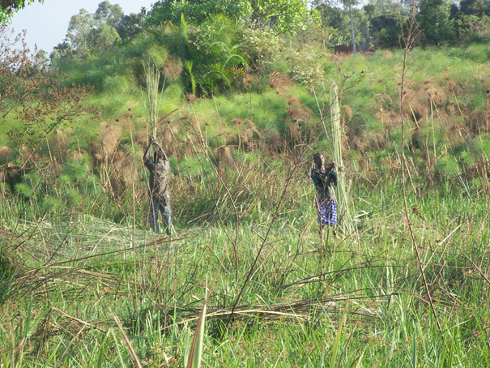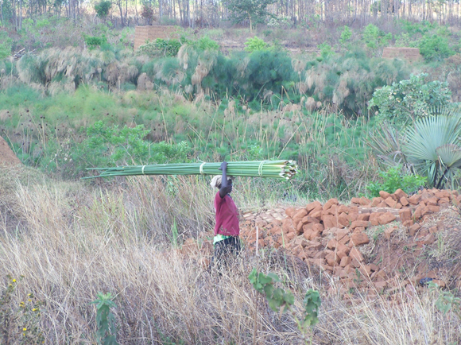

Plates 3a, 3b: Harvesting of papyrus and transporting it either home for processing or for sale in its raw form. Note the regenerating papyrus in Plate 3b.

Table 2 shows the education background of the people who extract resources from the wetland.

Table 2: Educational background of respondents at Pece wetland

Factor | Category | Frequency | Percentage(%)
Educational level attained | Secondary level not completed  Secondary level completed  Tertiary level (career) completed | 14  26  14 | 25.9  48.2  25.9
Years since left school | <10  11-20  >21 | 34  12  08 | 63  22.2  14.8
School environment setting | Urban  Peri-urban  Rural | 26  17  11 | 48.1  31.5  20.4
Occupation/ employment sector | Formal employment(salaried)  Informal employment(self)  Unemployed(not earning) | 20  22  12 | 37.0  40.7  22.2
Total |  | 54 | 100%

From the above table, a majority of respondents (63%) left school less than 10 years ago. School leavers found opportunities from wetlands to get startup capital (Asimo, 2007) for other businesses. Interestingly some respondents (48.1%) studied in urban schools.

The use of wetland resources was categorized and graded using a 3-Likerts scale as shown in Table 3. (L=Little; A=Average and M = Much)

Table 3: Wetland resources of Pece wetland and the percentage level of their usage at households per population

Household  population | Papyrus/  Grass/ree |  |  | Water |  |  |  | Animals |  |  | Agriculture /Food items /crops |  |  | Soil/clay/  Sand
 | L | A | M | L | A | M |  | L | A | M | L | A | M | L | A | M
<5 | 12.9 | 12.9 | 7.4 | 3.7 | 14.8 |  | 14.8 | 20.4 | 11.1 | 1.9 | 7.4 | 11.1 | 14.8 | 5.6 | 9.2 | 18.5
6-10 | 25.9 | 12.9 | 20.4 | 9.3 | 27.8 |  | 22.2 | 12.9 | 25.9 | 20.4 | 9.2 | 22.2 | 27.8 | 14.8 | 25.9 | 18.5
>10 | 1.9 | 1.9 | 3.7 | 0 | 1.9 |  | 5.6 | 5.6 | 0 | 1.9 | 1.9 | 1.9 | 3.7 | 1.9 | 3.7 | 1.9
Total % | 40.7 | 27.8 | 31.5 | 12.9 | 44.4 |  | 42.6 | 38.9 | 38.9 | 22.2 | 18.5 | 35.2 | 46.3 | 22.2 | 38.9 | 38.9

Wetlands offer resources such as water, clay, grass and other materials used for construction of huts or houses. Table 3 indicate that some people in addition to extracting resources also use the wetland for agriculture (46.3%) in households that consist of population 6-10 people. The use of water resource was the highest in all the categories of households (42.6%), while the extraction of soil/clay/sand was lower at (38.9 %). Differences in use of wetland resources by family household was significant at X² 0,348 p<0.05). The population in family of about 6-10 persons used the wetland resources more than because they were composed of many dependents (young children) and school going children and people who are not employed at formal salaried sector.
Environment officers and local council leaders in Pece prisons ward concurred with these findings as they reported:
“Many people settle in the wetland for easy survival. Wetlands provide a livelihood for many people at a perceived ‘free cost’”.
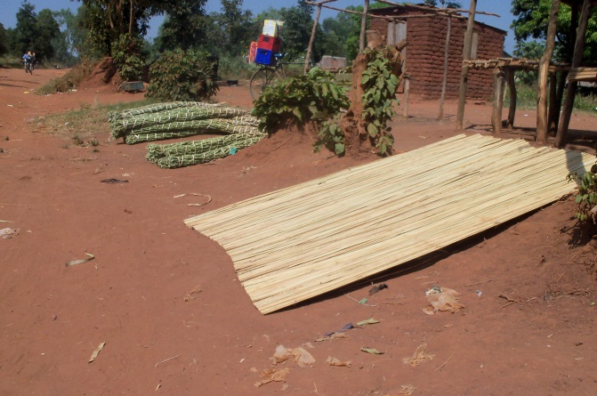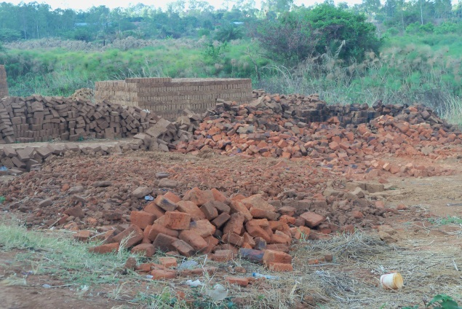

Plates 4a and 4b: Wetland resources from Pece wetland processed for sale: ropes and mats from papyrus at a roadside market, and bricks from clay/soil within the wetland.

Papyrus/grass/ reeds were recorded the least used wetland resource at 40.7% and by the 6-10 household population.

Application of the knowledge from Biology education learnt at school

Table 4 shows the results of the respondents on application of biology education

Table 4: Percentage level of Usage of wetland resources in teaching/learning of biology per educational background.

Educational  Background | Papyrus / Grass/ reeds | Water | Soil/ sand/ clay | Animals | Food items  /crops
 | L A H % | L A H  % | L A H  % | L A H  % | L A H  %
Below Secondary level | 7.4 7.4 11.1 | 12.9 0 12.9 | 16.1 1.9 7.4 | 11.1 12.9 1.9 | 9.3 9.3 7.4
Completed  Secondary level | 16.7 12.9 18.3 | 14.8 16.7 16.7 | 14.8 11.1 22.2 | 20.3 11.1 16.7 | 12.9 9.3 23.9
Completed Tertiary level | 12.9 9.3 3.7 | 7.9 5.6 12.9 | 9.3 9.3 7.4 | 11.1 9.3 5.6 | 12.9 3.7 9.3
Total % | 37 29.6 33.3 | 35.1 22.2 42.5 | 40.7 22.2 37 | 42.5 33.3 24 | 35.1 22.2 42.5
Key: L= low A= average H= high

Usage of water at 42.5% was recorded high but as a basic requirement for life, this is inadequately reflected in the content of the curriculum. Respondents use of little what they learned in secondary level not even in practical lessons. Some respondents new about the functions of wetlands as indicated in table 5.

Table.5: Level of Knowledge of functions and services of Pece wetland
Function and service | Frequencies  L A H | Percentages  Low % | Average % | High %
Water storage | 23 9 22 | 42.6 | 16.7 | 40.7
Water filtration | 19 9 26 | 35.1 | 16.7 | 48.1
Flood regulation | 21 13 20 | 38.9 | 24 | 37
Raw material provision | 18 12 24 | 33.3 | 22.2 | 44.4
Habitat for animals | 28 14 12 | 51.9 | 25.9 | 22.2

Water filtration was the highest known function by respondents of Pece wetland (48.1%). The clear flowing water of the wetland was evidence of this function to the residents as they stated:
“We observe the dirty water running on surface, and it drains into the wetland when it rains, but what flows along Pece wetland is clean water We learn this through the
conservation efforts by the District Environment Office, not in schools.”

However, it is known to the District Environmental officer that the resources economically attract people and he appreciates the fact that it would have been good if something about use of natural resources is taught in schools. One respondent said
“The natural resources like papyrus attract people here for money making”.

The extraction of these materials was not related to what was learnt in secondary schools.

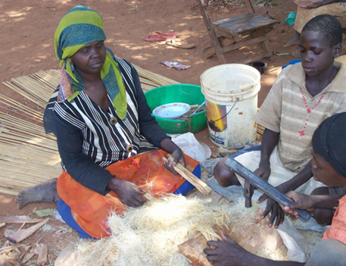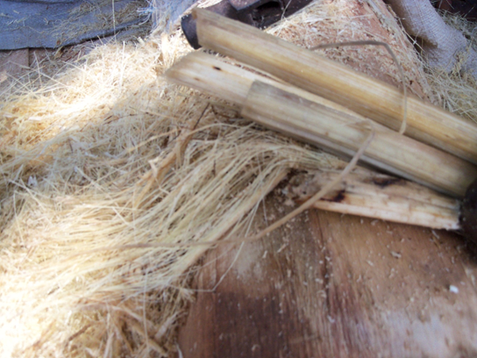

Plate 5a and 5b: Papyrus crashed locally at people’s home as a value addition process for making sanitary pads.

Other functions like water storage and flood regulation were known to some extent by the respondents (Table 5). Little of this is found in the content of the biology education taught at school yet many areas such as Pece wetland, are urbanising. In the focus group discussion they said:
“We know this wetland for papyrus, water and clay. These are the major things we get and use from Pece. Fish and other animals, maybe those olden days, but we don’t really see them.”

The use of the wetland resources would depend on the seasons, locations and at times the gender involved. Molding of bricks from soil and clay was dominated by young men and boys. The women mainly got soil to smear the floor and walls of the huts. Cultivation of some plants like sweet potatoes was seasonal while vegetables and sugar was named to be grown throughout the year due to the constant and above the land surface water levels. A community member from expressed that:
“At least in the wetland we can survive by digging and making brick but we do not learn this from schools”.

A good portion of foodstuff, especially vegetables, was produced from the wetland during the dry season. Many women move round buying and selling vegetables and other food stuff, a petty trade called “ Awaro”.
‘Much of these vegetables grown in the wetland are bought from the garden by the women and again sold to people at their homes or by the road side market. The other women wait by the roads to buy foodstuffs from afar then sell to the people around. We call these women “the Awaro”’

Some people specialize in cultivation in the wetland for vegetables throughout the year.

The education background has no significant influence on the use of biological resources X2 , = 0.43 (P<0.05). Thus, the recall and reference of knowledge from biology taught at school had no significant influence on the use of wetland resources by school leavers around Pece wetland.
The curriculum developer on biology subject noted that teaching and learning of biology was now tending to focus on passing of examinations (Ntale, . He regrettably said:
“Cram work nowadays is more appealing to students rather than understanding, yet biology as a subject is dynamic”.

The communities’ use of wetland resources appears to be based on knowledge passed to them through other sources rather than that from classroom.

“I saw it from my mother, so I learnt. We have been making mats and ropes from papyrus for sale for many years. ”

‘My parents used to dig in the wetland during the dry seasons. When I was of age I joined them in the cultivation for vegetables during the dry season in the wetland in the village. Now I also bring my children and teach how to dig and even fish in Pece wetland here’.

The family or traditional values were still influential in aspects of natural resources use (Oryemo, 2008). However hope to apply knowledge learnt from school biology lesson was given by one officer who was about to retire:
“While at school in the study of nature science, we saw fish growing in small ponds. Now after government service, my plan is fish farming. I have set on digging some ponds besides the wetland for fish farming, somewhere in Pece there. Those early days, we used to get big fish from this wetland, and I believe fish can still do well there. Some field workers, specialists on fish farming are helping us in setting up this project”.

Fish, as a wetland resource, was affected by over-harvesting
“Our current population does not have enough food to eat especially for proteins. Fish farming is one means out and they can grow from here even naturally. We used to have fish in this wetland, and I am going to introduce them into these ponds. With maintenance, these ponds will not dry up and the fish will also supplement my income.”

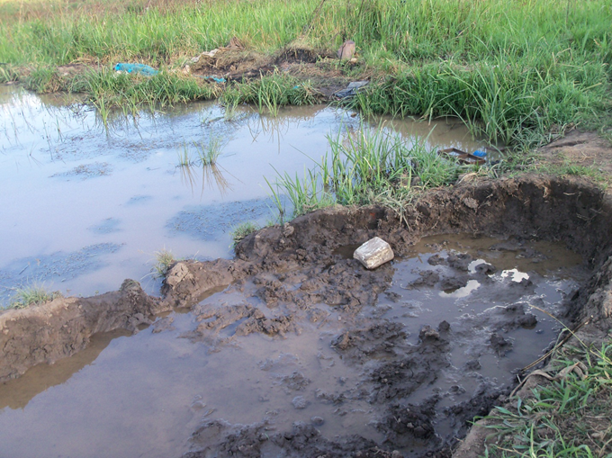

Plate 6: Ponds for fish farming under preparation from clay extraction burrows left after making bricks.

Biology education could clearly be seen as a likely intervention in sustainable livelihood and so its knowledge, skills and values be translated into natural resources use and conservation (Oonyu, 2003, Warren 1995).

The identification of conservation skills acquired through the learning of biology that are necessary in the use of wetland resources.

The levels of education and the application of skills of biology education in extraction of materials from the wetlands are shown in table 6 below.

Table 6 The percentage of biology education influences on skills of extraction and wise-use of wetland resources (L = low A = average H= high)

Educational  Level | Papyrus/grass  L A H | Water  L A H | Animals  L A H | Food crops  L A H | Soil/clay/sand  L A H | Mean  L A H
Completed Secondary | 16.7 2.9 18.5 | 14.8 3.7 16.7 | 14.8 11.1 22.2 | 20.4 11.1 18.5 | 12.9 9.2 25.9 | 43 26 54
Below  Secondary | 7.4 7.4 11.1 | 12.9 12.9 12.9 | 16.7 1.9 7.4 | 11.1 12.9 1.9 | 9.2 9.2 7.4 | 31 27 22
Completed Tertiary | 12.9 9.2 3.7 | 7.9 5.6 12.9 | 9.2 9.2 7.9 | 11.1 9.2 5.6 | 12.9 3.7 9.2 | 29 20 19

Where by low was counted and rated as 2 or less times; average as 3 – 5 times; high as 6 or more times.

Soil and clay was mostly used for moulding bricks used for construction of huts and houses. The processed soil and clay was also one of commonest source of income for supporting livelihood. Skills for processing were low (7.9%) yet they had no alternatives to add value. Skills application on use of wetland resources of Pece wetland could be attributed to attainment of biology curriculum which excluded wise -use of the resources people extract from natural environments. The teaching of biology is inadequate in addressing the link of resource identification to wise-use of natural resources in the environment (Kafuko, 2001). The curriculum development officer noted that specific emphasis on conservation of biological or natural resources such as wetlands resources was generally lacking.
“It is just the individual teachers who emphasize the issue of conservation through various teaching methods and in the content of their interest”.

The teachers’ responses during the focus group discussion generally concurred that they teach what is presented in the syllabus and aspects needed to pass examinations. Already they are face with problems of teaching ecology (Isingoma, 2005).
“Practical environmental conservation can be done in wildlife, environment and other clubs and this is extra curriculum and expensive.”

The teachers did not indicate the effectiveness of extra curriculum skills acquired and practiced from biology education taught at school (Arinaitwe, 2007). A sustainable was of using these wetland resources could be influenced through biology education by promoting skills acquired. The teachers themselves have already noted that they what they are teaching is not relevant to many students who drop out of school (Education News, 2010). What is relevant is got from non-formal education sectors such as workshops and media, besides family and traditional knowledge passed onto the young ones.
“The youth have more interest in other issues of entertainment like Sex Education, drama and music” “What is taught at school is similar to the home teaching”.

A specific approach to environmental education related issues needs to be designed or improved to capture more attention of the youth through in-service training is encouraged (Mbidde et al, 2009), however this should be incorporated in the syllabus and coupled with non-formal education in the community and the level to which they contribute to skills development for wise use of wetland resources could be complementary.

“No organization comes here to teach us or meet us on environment or wetland matters, but we just hear of environment officers from the radio”.

Conclusion:
The community was aware that the needed resources from nature i.e fish, papyrus, sand and safe water for human to drink. However, the sustainable was to use these resources should be encouraged and taught in schools (Nixon et al 1999). Hence disasters of environmental degradation like contamination of spring water wells which were safe and clean for human consumption continue. Traditional sustainable uses are not documented and referenced in our books and in addition many organisms have also disappeared due to habitat loss some of them before they are known to science. There is a lot of inclination that pupils who study biology should do health related courses yet many opportunities exist in the biology education sector. Hence there is need to readdress the curriculum of biology to include aspect of use of renewable natural resources which include the organisms and their ways of life. In this way we shall be assured of sustainable development in Africa.

References:
Arinaitwe, K. (2007). Challenges of Science Education in Africa: the Ugandan Scene. World Association of Young Scientists.
Aryemo Joyce Latigo (2008). Community Utilization and Conservation of Pece Wetland, Gulu Municipality, Gulu District- Uganda. Makerere University Kampala.
Asimo Harriet J. Okuni (2007): Environmental Awareness, Attitudes and Practices of Secondary School Biology Students. Makerere University Kampala.
Basemera, P. L. (2003). The Use of Indigenous Knowledge in the Conservation of Biological Diversity in Sango Bay, Rakai District, Uganda. Makerere University Kampala
Education News (2010). Review Biology Syllabus, teachers plead. Education News Limited, Kampala.
Isingoma, S. (2005). Problems encountered in the teaching of Ecology at O, level in Masindi District. Makerere University Kampala.
Kafuko, C. C. W. (2001). Biology learning and environment awareness among students at N.T.Cs. Makerere University Kampala.
Kizito, M. Everest (2008): World Environment Day: A Chance to Play our Part. NEMA NEWS, Vol. 6, No, 4 June 2008. Pg 2.
Mbidde Henry, Miho Ito, (2009) Monitoring and Evaluation Survey SESEMAT – INSET Project. Ministry of Education and Sports, Japan International Cooperation Agency.
Ministry of Education and Sports, (2008). Biology Teaching Syllabus, Uganda Certificate of Education. Senior 1-4. National Curriculum Development Centre, Kampala.
Ministry of Education and Sports,(2005). Education Sector strategic Plan 2004-2015. The Republic of Uganda, Kampala.
Mwanje Simon, (2010): Biodiversity Destruction: A Threat to Human Well Being. NEMA NEWS, Vol. 8 No. 2 , June 2010.
National Environment Management Authority, (2006). District State of Environment Report for Gulu, 2006. National Environment Management Authority. Kampala
National Environment Management Authority, UNDP, (2008). State of Environment Report for Uganda 2008. National Environment Management Authority. Kampala.
National Environment Management Authority, (2010). State of Environment Report for Uganda 2010. National Environment Management Authority. Kampala.
Nixon J. Sankey K., Furauy A., Simmons M., (1999). Education for sustainability in Scottish Secondary Schools- Environmental Education Research.
Ntale J. (2003). Major Factor Influencing ‘O’ Level Biology Teachers’ Choice of Teaching in Selected School in Kampala. Makerere University Kampala.
Olaniyan, A. David & Okemakinde, T. (2008). Human capital theory: Implications for educational development. University of Ibadan, Ibadan.
Oonyu, J. (2000). Impact of Non-formal Environment Education Programmes on Environment Awareness, Attitudes and conservation Practices of Local Communities Living around Mt. Elgon National Park. Makerere University Kampala.
Oonyu, J., Busulwa, S. H. (2009). Understanding Our Wetlands. A Resource Book for Primary/Secondary Schools.
Pomeroy, D.E, Service, M.W., Egonjobi, J.K.E., Dickson, N., (1986). Tropical Ecology. Longman Group UK limited.
Republic of Uganda, (1992). Government White Paper on Education. Kampala.
Schultz, T. W. (1971): Investment in Human Capital; The Role of Education and of Research. New York, The Free Press.
Warren, D.M. (1995). Indigenous Knowledge: Biodiversity Conservation and Development, Conservation of Biodiversity in Africa: Local Initiatives and Institutional roles. National Museum of Kenya.

